Plutas - Product & Decision Experience Observations
(This case study is based on a proposal / product observation and does not disclose confidential data.)
What Plutas Is Doing Well & Where the Real Opportunity Is --
Plutas has strong AI and climate risk intelligence.
The main challenge isn’t what the system can do, but how clearly that intelligence is translated into something business users can understand and act on.
What Plutas Is Doing Well
Plutas.ai = AI-driven climate risk intelligence for insurers, lenders & enterprises
- Strong AI + climate risk modelling
- Technically credible, actuarially sound platform
- Well-suited for regulated, high-stake decision environments
- Quote, pricing, triggers, thresholds, geography, and data sources are clearly computed and reliable

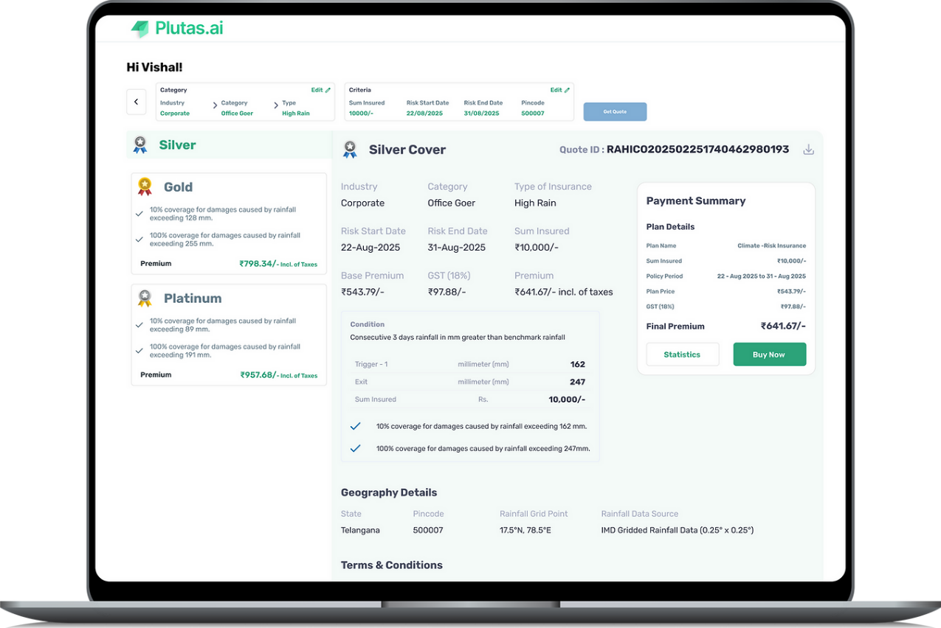
(Current experience demonstrates strong data & pricing logic, but expects users to interpret rather than decide.)

Core Challenge (Visible in the Current Experience)
While the system is powerful, its value is hidden inside complexity.
Today, the experience feels:
- Data-heavy
- Analyst-oriented
- Dependent on user interpretation
For example, on the quote screen:
- Users see rainfall triggers, exit thresholds, coverage percentages, premiums, and grids
- But the system does NOT clearly answer:
  - Which plan is best for me?
  - What am I risking if I choose Silver vs Gold vs Platinum?
  - What decision should I confidently take right now?
The user is asked to analyse, not decide.

The Real Opportunity
Turning complex climate + AI signals into clear, confident business decisions
What business users actually want to know:
- Should we insure this asset?
- Is this loan safe over the policy period?
- Which level of risk exposure should we act on now?
Winning here is not about better AI — it’s about decision clarity.

Where I Add Direct Value (Without Building a Large Team)
My contribution sits at the intersection of Product, UX, and Business Narrative — translating intelligence into action.

1. Reframe Features Into Outcomes
From
- Risk scores
- Rainfall thresholds
- Coverage percentages
- Technical policy conditions
To
- Approve / Reject / Mitigate / Monitor
- Basic protection vs full business continuity
- Low confidence vs high confidence decisions
The goal is to make the value visible in seconds, not slides — especially on key screens like plan comparison and checkout.
2. Design Experiences That Surface Decisions, Not Data
Applied directly to the current quote screen:
- Progressive disclosure instead of showing everything at once
- Clear risk confidence indicators
- A visible system recommendation with reasoning
- “What should I do next?” built directly into the UX
This shifts the experience from reading numbers to taking action.

3. Create Role-Based Narratives
Different users decide differently — the UX and messaging should reflect that:
- Insurers → underwriting confidence & loss predictability
- Lenders → portfolio risk, long-term exposure & compliance
- Enterprises → asset protection & operational continuity
The same AI, explained through different decision lenses.

Execution Reality
- Can be driven initially by one senior product/UX leader
- No large team required upfront
- Team scales after clarity, adoption, and traction are proven

Why This Matters?
This is a leverage role:
- Small, focused input
- High impact on adoption, trust, and conversion
- Direct alignment with Plutas’ business goals
Plutas already has the intelligence — this role unlocks its business value.

